

C PROJECT REPORT ON
Matrix Tools and Operations

SUBMITTED TO
The Technical Department
KG College of Arts and Science

SUBMITTED BY
Student Name | Roll No. | Course & Batch
JAYADHANUSHIKA | 25BIT116 | I-B.SC-IT-’B’  (2025-2028)
JEEVA | 25BIT117 | I-B.SC-IT-’B’  (2025-2028)
JENILEYA | 25BIT118 | I-B.SC-IT-’B’  (2025-2028)
KABISH | 25BIT120 | I-B.SC-IT-’B’  (2025-2028)

Academic Year: 2025 – 2026
Semester: I

DECLARATION
We hereby declare that the project entitled “MATRIX TOOLS AND OPERATIONS” submitted in partial fulfilment of the requirements for the course [ C PROGRAMMING] is a record of our original work carried out under the guidance of [VASANTHKUMAR], Technical Trainer, Technical Department, KGiSL MicroCollege.
We further declare that this project has not been submitted previously, either in part or in full, for the award of any degree, diploma, or other similar title, at this or any other institution.
We have acknowledged all sources of information used in this project wherever applicable.
Student Name | Roll No. | Course & Batch | Signature
JAYADHANUSHIKA | 25BIT116 | I-B.SC-IT-’B’  (2025-2028)
JEEVA | 25BIT117 | I-B.SC-IT-’B’  (2025-2028)
JENILEYA | 25BIT118 | I-B.SC-IT-’B’  (2025-2028)
KABISH | 25BIT120 | I-B.SC-IT-’B’  (2025-2028)

Place: COIMBATORE
Date: ______________

CERTIFICATE
This is to certify that the project entitled “Matrix Tools and Operations” is a bonafide work carried out by the following students of [I-Bsc.IT - B], [INFORMATION TECHNOLOGY], KG College of Arts & Science, in partial fulfilment of the requirements for the course [C PROGRAMMING].
This project has been completed under my supervision and guidance during the academic period [NOVEMBER, 2025].
It is further certified that this project is the original work of the students and has not been previously submitted for the award of any degree, diploma, or certificate at this or any other institution.
Project Team:
S. No. | Name | Roll Number
1. | JAYADHANUSHIKA | 25BIT116
2. | JEEVA | 25BIT117
3. | JENILEYA | 25BIT118
4. | KABISH | 25BIT120

Guide: Head of the Department
(Technical Trainer, KGM) (Technical Head, KGM)

______________________ _______________________

Place:
Date:

ABSTRACT
The project “Matrix Tools and Operations” is developed using the C programming language to perform various mathematical operations on matrices. The main objective of this project is to simplify matrix computations such as addition, subtraction, multiplication, and transpose using a structured and user-friendly approach.
The system allows users to input matrices of different sizes and perform operations through a menu-driven interface. It ensures accuracy in calculations and provides results instantly. The program demonstrates the use of arrays, functions, loops, and conditional statements in C language
This project helps in understanding mathematical problem-solving using programming and improves logical thinking. It is useful for students and beginners to learn matrix operations efficiently through coding.

TABLE OF CONTENTS
S. No. | Topics | Page. No.
1 | Introduction
1.1 | Objective
1.2 | Overview
1.3 | Features
2 | Program Analysis
2.1 | Problem Definition
2.2 | Project Overview
2.3 | Scopes and Limitations
3 | System Design
3.1 | Modules
4 | Methodology
4.1 | Problem Analysis
4.2 | System Design
4.3 | Program Development
4.4 | Testing and Validation
4.5 | Result and Documentation
4.6 | Algorithm
4.7 | Flowchart
5 | Source Code
6 | Input and Output Screens
7 | Discussion and Conclusion
7.1 | Discussion
7.2 | Conclusion
8 | References

1.INTRODUCTION

1.1 Objective
- To develop a Matrix Operations system using C programming
- To perform operations like addition, subtraction, multiplication, and transpose
- To demonstrate structured programming concepts using arrays and functions

1.2 Overview
Matrix operations are widely used in mathematics, engineering, and computer science. This system allows users to:
- Enter matrix elements
- Perform different matrix operations
- Display results in matrix format

1.3 Features
- Menu-driven program
- Supports multiple matrix operations
- Easy-to-understand output
- Efficient calculations Menu stored in arrays for easy access.

2. PROGRAM ANALYSIS

2.1 Problem Definition
Manual matrix calculations are time-consuming and error-prone. A system is required to:
- Accept matrix inputs
- Perform operations automatically
- Display accurate results

2.2 Project Overview
Aspect | Description
Language Used | C
Compiler | GCC / Dev-C++ / Turbo C++
Concepts Used | Arrays, Functions, loops
I/O Type | Console-based

2.3 Scopes and Limitations
Scope:
- Useful for students learning matrix operations
- Can be extended to advanced operation
Limitations:
- Works only in console mode.
- No graphical interface.
- Limited to basic operations

- SYSTEM DESIGN
3.1 Modules
The Matrix Tools and Operations is divided into multiple functional modules, each handling a specific part of the program. These modules work together to make the system more efficient and user-friendly.
Module Name | Description
Input Module | Accepts matrix size and elements from the user
Addition Module | Add two matrices
Subtraction Module | Subtracts two matrices
Multiplication Mode | Prforms matrix multiplication
Transpose Module | Finds transpose of a matrix
Display Module | Displays matrix results

4.METHODOLOGY
The development of the project Matrix Tools and Operations follows a structured methodology that includes five main stages: Problem Analysis, System Design, Program Development, Testing & Validation, and Results & Documentation.
4.1. Problem Analysis
Matrix operations were analyzed and broken into smaller steps like input, processing, and output.
4.2. System Design
Matrices are stored using 2D arrays. Functions are used for each operation
4.3. Program Development
The program is written in C using Arrays for storing matrices Functions for Operations Loops for calculations
4.4. Testing and Validation
After coding, each module was tested individually to check correctness.
Tested with different matrix sizes Verified results manually Checked invalid inputs
4.5. Result and Documentation
The program successfully performs all matrix operations and displays correct outputs.
4.6. Algorithm
An algorithm is a step-by-step logical procedure used to solve a specific problem or perform a computation.
Step-by-step:
Start
Input matrix size
Enter matrix elements
Display menu
Choose operation
Perform selected operation
Display result
Stop
Purpose of the Algorithm
The main purpose of using an algorithm in this project is to:
- Define the logical flow of the billing operations.
- Ensure accuracy in calculations like subtotal, GST, and total amount.
- Provide a structured path for program development before actual coding.
- Make the system easy to understand, debug, and enhance in the future.
Algorithm in the Project
Step-by-Step Procedure:
Start the program
Declare variables
Declare matrices A, B, and Result
Declare variables for rows (r), columns (c), and choice
Input matrix size
Read number of rows and columns from the user
Input Matrix A
Use nested loops to read elements of matrix A
Input Matrix B
Use nested loops to read elements of matrix B
Display menu
Show options:
Addition
Subtraction
Multiplication
Transpose
Read user choice
Perform operation using switch case
If choice = 1 (Addition):
For each element
Result[i][j] = A[i][j] + B[i][j]
If choice = 2 (Subtraction):
Result[i][j] = A[i][j] - B[i][j]
If choice = 3 (Multiplication):
Use three nested loops
Result[i][j] = Σ (A[i][k] × B[k][j])
If choice = 4 (Transpose):
Transpose[j][i] = A[i][j]
Else:
Display “Invalid choice”
Display result matrix
4.7. Flowchart
The flowchart represents the logical flow of the Matrix Tools and Opertions. It visually outlines the sequence of operations — from displaying the menu to generating the customer bill — ensuring clarity in how data moves through each stage of the program.
Explanation of Flowchart:
1.Start The program begins execution.
2.Input Rows and Columns User enters: Number of rows Number of columns This defines the matrix
3.Input Matrix A User enters elements of first matrix using loops.
4.Input Matrix B User enters elements of second matrix.
5.Display Menu Program shows available operations: Addition, Subtraction, Multiplication,
Transpose
6.Enter Choice User selects the operation using a number (1–4).
7.Decision Making (Switch Case)Based on user choice:
➤If Choice = 1 (Addition)Add corresponding elements Result[i][j] = A[i][j] + B[i][j]
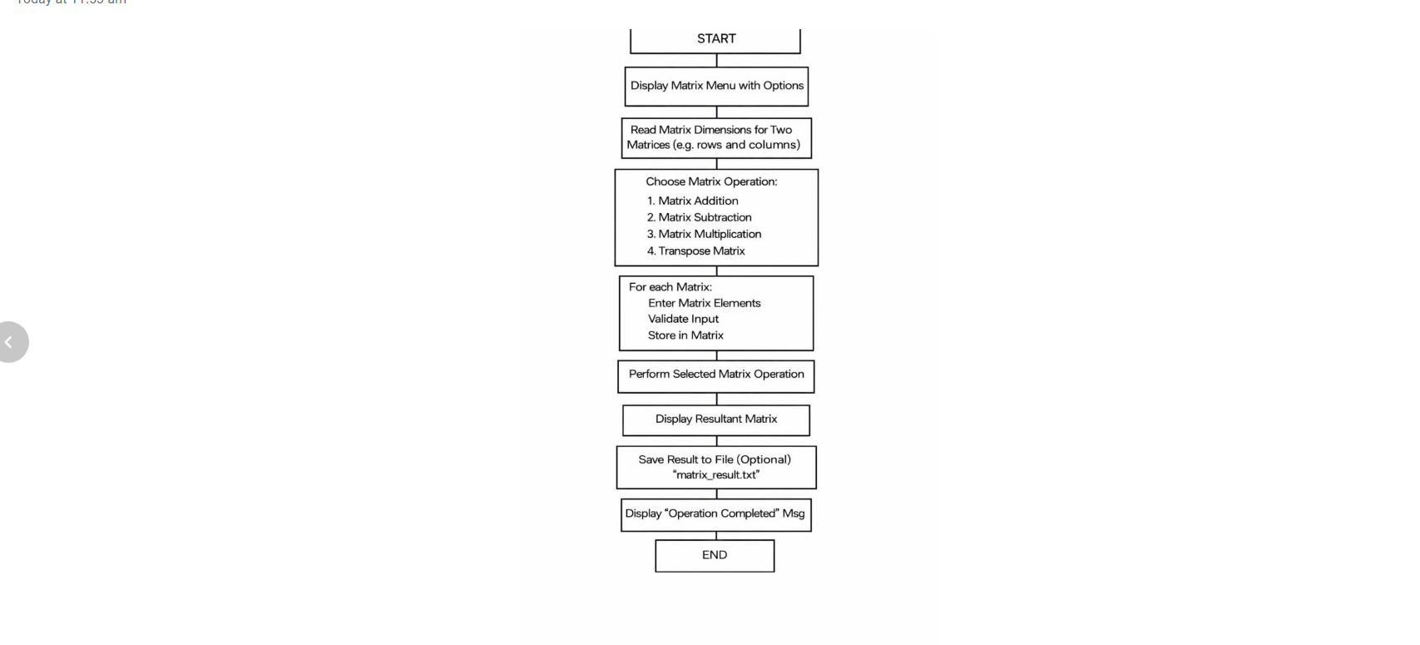

5.SOURCE CODE

#include <stdio.h>
#define MAX 10
void inputMatrix(int matrix[MAX][MAX], int r, int c) {
for(int i=0;i<r;i++) {
for(int j=0;j<c;j++) {
printf("Enter element [%d][%d]: ", i, j);
scanf("%d", &matrix[i][j]);
}
}
}
void displayMatrix(int matrix[MAX][MAX], int r, int c) {
for(int i=0;i<r;i++) {
for(int j=0;j<c;j++) {
printf("%d ", matrix[i][j]);
}
printf("\n");
}
}
void addMatrix(int a[MAX][MAX], int b[MAX][MAX], int r, int c) {
int result[MAX][MAX];
for(int i=0;i<r;i++)
for(int j=0;j<c;j++)
result[i][j] = a[i][j] + b[i][j];
printf("\nResult (Addition):\n");
displayMatrix(result, r, c);
}
void subtractMatrix(int a[MAX][MAX], int b[MAX][MAX], int r, int c) {
int result[MAX][MAX];
for(int i=0;i<r;i++)
for(int j=0;j<c;j++)
result[i][j] = a[i][j] - b[i][j];
printf("\nResult (Subtraction):\n");
displayMatrix(result, r, c);
}
void multiplyMatrix(int a[MAX][MAX], int b[MAX][MAX], int r1, int c1, int c2) {
int result[MAX][MAX];
for(int i=0;i<r1;i++) {
for(int j=0;j<c2;j++) {
result[i][j] = 0;
for(int k=0;k<c1;k++) {
result[i][j] += a[i][k] * b[k][j];
}
}
}
printf("\nResult (Multiplication):\n");
displayMatrix(result, r1, c2);
}
void transposeMatrix(int matrix[MAX][MAX], int r, int c) {
int transpose[MAX][MAX];
for(int i=0;i<r;i++)
for(int j=0;j<c;j++)
transpose[j][i] = matrix[i][j];
printf("\nTranspose:\n");
displayMatrix(transpose, c, r);
}
int main() {
int a[MAX][MAX], b[MAX][MAX];
int r, c, choice;
printf("Enter rows and columns: ");
scanf("%d %d", &r, &c);
printf("\nEnter Matrix A:\n");
inputMatrix(a, r, c);
printf("\nEnter Matrix B:\n");
inputMatrix(b, r, c);
printf("\n1. Addition\n2. Subtraction\n3. Multiplication\n4. Transpose\n");
printf("Enter choice: ");
scanf("%d", &choice);
switch(choice) {
case 1: addMatrix(a,b,r,c); break;
case 2: subtractMatrix(a,b,r,c); break;
case 3: multiplyMatrix(a,b,r,c,c); break;
case 4: transposeMatrix(a,r,c); break;
default: printf("Invalid choice");
}
return 0;
}
SOURCE CODE EXPLANATION:
1) Headers & Macros
#include <stdio.h>
#define MAX 10
Explanation:
stdio.h → Used for input and output functions like printf() and scanf().
#define MAX 10 → Defines the maximum size of the matrix (10×10).
This avoids using large memory and keeps the program controlled.

2) Function: Input Matrix
void inputMatrix(int matrix[MAX][MAX], int r, int c)
- Purpose:
To read matrix elements from the user.
Working:
Uses nested loops:
Outer loop → rows
Inner loop → columns
Each element is stored as
- scanf("%d", &matrix[i][j]);
- Logic:
It fills the matrix row by row.

3) Function: Display Matrix
void displayMatrix(int matrix[MAX][MAX], int r, intc)
Purpose:
To print matrix in proper format.
Working:
Uses nested loops to print each element.
printf("%d ", matrix[i][j]);
Output Format:
1 2 3
4 5 6

4) Function: Addition of Matrices
void addMatrix(int a[MAX][MAX], int b[MAX][MAX], int r, int c)
Purpose:
To add two matrices.
Formula:
Result[i][j] = A[i][j] + B[i][j]
Working:
Loops through each element.
Adds corresponding elements of both matrices.
Stores result in a new matrix.

5) Function: Subtraction of Matrices
void subtractMatrix(int a[MAX][MAX], int b[MAX][MAX], int r, int c)
Purpose:
To subtract matrices
\
Formula:
Result[i][j] = A[i][j] – B[i][j]
Working:
Similar to addition.
Subtracts element by element.

6) Function: Multiplication of Matrices
void multiplyMatrix(int a[MAX][MAX], int b[MAX][MAX], int r1, int c1, int c2) Purpose:
To multiply two matrices.
Condition:
Number of columns of A = Number of rows of B
Formula:
Result[i][j] = Σ (A[i][k] × B[k][j])
Working:
Uses three nested loops:
i → rows of A
j → columns of B
k → multiplication process

7) Function: Transpose of Matrix
void transposeMatrix(int matrix[MAX][MAX], int r, int c)
Purpose:
To convert rows into columns.
Formula:
Transpose[j][i] = Matrix[i][j]
Working:
Swaps row index with column index
1 2 1 3
3 4 → 2 4

8)Main Function
int main()
Variables:
int a[MAX][MAX], b[MAX][MAX];
int r, c, choice;
a, b → Matrices
r, c → Rows and columns
choice → User option

9) Input Section
scanf("%d %d", &r, &c);
User enters matrix size.
inputMatrix(a, r, c);
inputMatrix(b, r, c);
Calls function to input matrices

10) Menu Display
printf("1. Addition\n2. Subtraction\n3. Multiplication\n4. Transpose\n");
Displays list of operations.

Control Flow Summary
- Start program
- Input matrix size
- Input matrix A and B
- User selects operation
- Perform operation
- Display result
- End the program

INPUT AND OUTPUT SCREENS
Output Screen:
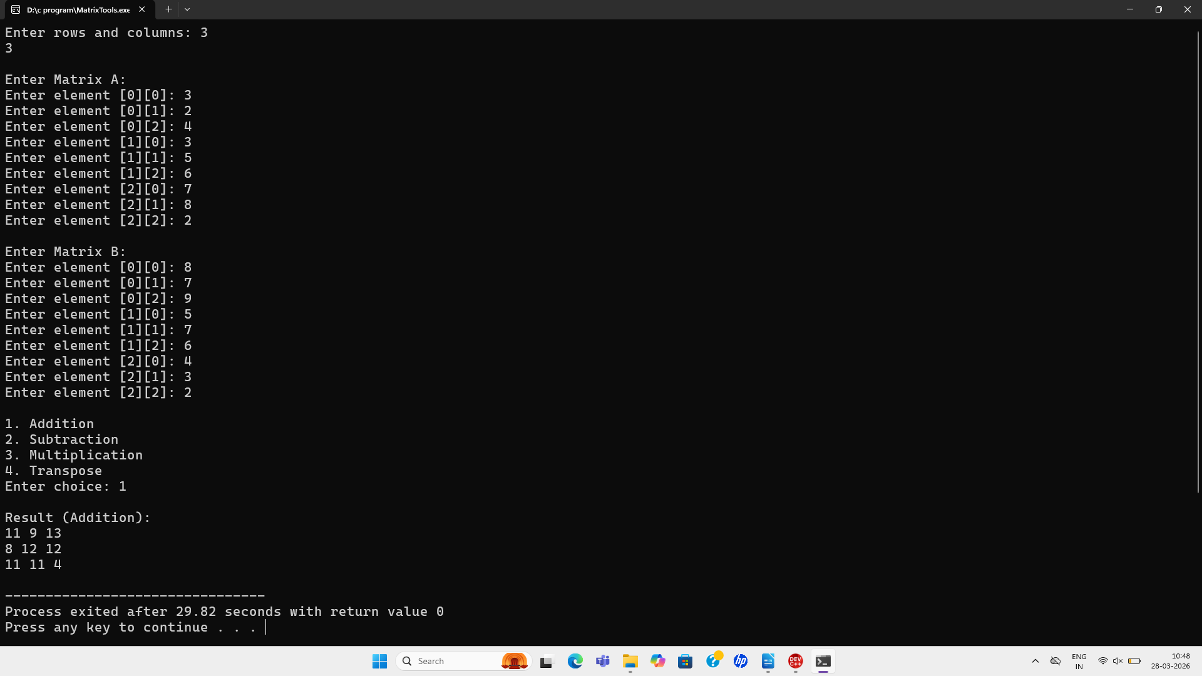

- DISCUSSION & CONCLUSION

7.1 Discussion
The project demonstrates:
Use of arrays and functions
Efficient matrix computation
Structured programming

7.2 Conclusion
The project demonstrates:
Use of arrays and functions
Efficient matrix computation
Structured programming

REFERENCES

- The C Programming Language – Kernighan & Ritchi
- GeeksforGeeks – Matrix Operations in C
- TutorialsPoint – C Programming
- Dev-C++ User Manual

